Report
Amazon is an American multinational technological company it is the largest online retailer and technology provider. Originally started as an online book selling company it has transformed into an internet-based business enterprise providing different services such us digital streaming and Artificial intelligence. Its headquarters are in Seattle. Amazon has individual websites, software. The company allows authors musicians, film-makers, and others to sell and publish content. Amazon prime which was introduced I 2005 is a membership programme built on the foundation of unlimited fast, free shipping now includes free one day delivery, Prime video amazon music, free two-hour grocery delivery, prime reading, prime gaming. Amazon photos etc. There is a whole sale foods market which has been leading the natural and organic foods retailer for 40 years. As the first certified organic grocer. Whole foods market has more than 500 stores in the United Kingdom, Canada, and US. Amazon helps small and medium-sized enterprises (SMEs) get online and access hundreds of millions of customers around the world. Now we have more than 65,000 UK SMEs selling professionally on Amazon’s stores, up almost 20% year-on-year. The total permanent workforce of around 75000 employees makes Amazon one of the to 10 private sector employers in the UK. Employees are spread across the UK in a wide variety of corporate and technology functions in Amazon and Amazon web services. There are 25 fulfilment centres and dozens of delivery stations across the UK. Amazon has invested 56 billion pounds into the UK since 2010.
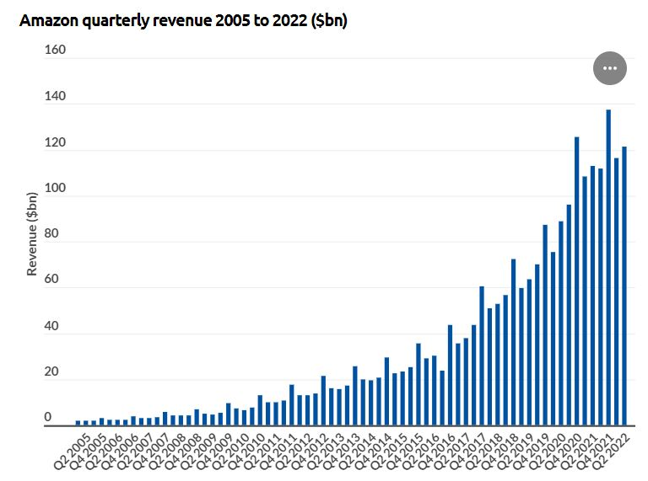
According to a news release on Amazon’s investors relation website, Amazon experienced a significant increase in net sales, but a decrease in operating income in the first quarter of 2022. Net sales increased by 7% to $116 billion In the first quarter. Operating income decreased to $3.7 billion in the first quarter, compared to $8.9 billion in the first quarter of 2021. The net loss was $3.8 billion in the first quarter compared with net income of $8.1 billion in the first quarter of 2021. Amazon is the third largest public company by revenue in the world, behind Walmart and China’s State Grid. Amazons Revenue increased by 11.9% in 2023 to $574 billion.
From the graph we can see that Amazons Revenue has increased steadily from 2005 to 2022. This highest rate of revenue we can see is 138 in Q2 of 2021 and the lowest at Q2 2005. From Q2 2016 to Q4 2017 we see the biggest increase in revenue from $40bn to $60bn.

