**Instructions:**

1. After deriving the intrinsic share price based on our model, the next step is to focus on putting together a report with an investment recommendation.
2. You are required to fill in the report template below using the sample report attached and your readings on the company’s guidance in terms of key segments and products.
   1. Identify two to three key products that are vital for the company’s growth and you can discuss about the trends and expectations. But remember to keep them all short cause and effect sentences.
3. You can take up to two days for this task and feel free to reach out to me if you have any questions.

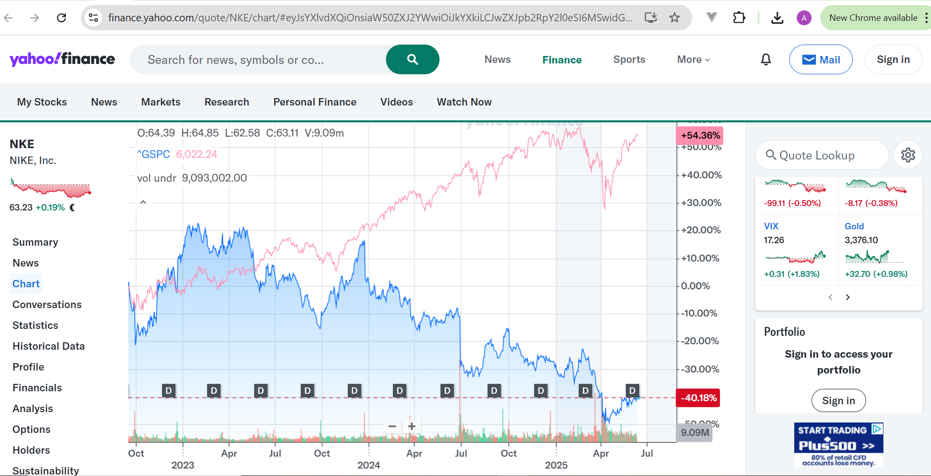

**Point 3:** EPS, FCFF and Capex forecasts. Any future developments, company’s key drug pipeline/development.

EPS increases from $3.83 in 2022 to $4.91 in 2027 at a rate of about $2 billion annually due to share buybacks. By 2027, FCFF will have grown to $8.07 billion, covering Capex (around 0.8% of sales). Performance Innovation in apparel through internet platforms boosts expansion.

**Point 2:** Margin of the group EBITDA, each segment’s contribution to earnings. The expectation of the margin growth. Key cost trends according to historic numbers (R&D).

North America accounts for 76% of the group's EBITDA margin, which stabilizes at about 14.7% through 2027. Growing SG&A (31.7% of 2022 sales), which is fueled by marketing, limits margin growth. In supply networks, cost control promotes profitability.

**Investment thesis:**

Short 2 line summary of the stock’s expected performance, based on your model.

NIKE’s stable revenue growth and strong cash flows are offset by high valuation. Our model suggests limited upside, recommending a hold due to balanced growth and risks.

**Point 1:** Comment on revenue growth expectation, key segment and product performance (not required to talk about all, which is the main segment and the main product that can impact the revenue growth the most)

Through 2027, revenue is expected to increase at a 4.9% CAGR, with North America accounting for 39% of 2022 sales. Growth is fueled by footwear, especially Air Jordan, because of its high price and cultural appeal. Nike Air Max uses creative designs to boost sales.

Company Name: NIKE, Inc.

Ticker: NKE

Current Share Price: $112.69

Upside/Downside to current share price: ((Forecasted Price – Current Price)/Current Price): -40.8%