Free Cash Flow Analysis: TechNova Inc.

# 1. Introduction

Free Cash Flow (FCF) represents the cash, a company generates, after accounting for capital expenditures needed to maintain or expand its asset base. It is a critical indicator of a firm's financial flexibility and investment potential.

# 2. Calculations

Formulas used:

Operating Cash Flow (OCF) = Net Income + Depreciation & Amortization + Changes in Working Capital

Free Cash Flow (FCF) = Operating Cash Flow - Capital Expenditures

|  |  |  |  |  |  |
| --- | --- | --- | --- | --- | --- |
| Year | OCF ($) | FCF ($) | Net Income ($) | Depreciation ($) | CapEx ($) |
| 2021 | 90,000 | 60,000 | 80,000 | 15,000 | 30,000 |
| 2022 | 102,000 | 67,000 | 90,000 | 18,000 | 35,000 |
| 2023 | 113,000 | 73,000 | 100,000 | 20,000 | 40,000 |

Step-by-step Calculations:

Year 2021:

OCF = 80,000 + 15,000 + (-5,000) = 90,000

FCF = 90,000 - 30,000 = 60,000

Year 2022:

OCF = 90,000 + 18,000 + (-6,000) = 102,000

FCF = 102,000 - 35,000 = 67,000

Year 2023:

OCF = 100,000 + 20,000 + (-7,000) = 113,000

FCF = 113,000 - 40,000 = 73,000

Free Cash Flow Trend (2021–2023):

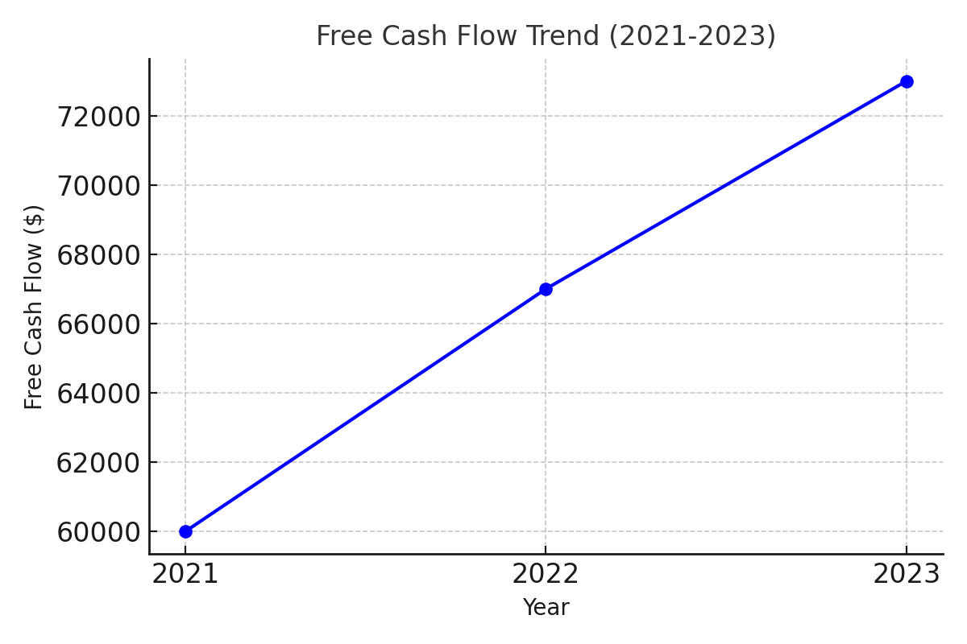

# 3. Analysis of FCF Trends

From 2021 to 2023, TechNova Inc.'s Free Cash Flow increased steadily from $70,000 to $87,000. This upward trend is a strong indicator of improving financial health and operational efficiency. The increasing Net Income and controlled Capital Expenditures suggest the firm is effectively managing its core operations while reinvesting sustainably in long-term assets. Moreover, consistent increases in Depreciation & Amortization show active asset utilization. While the changes in working capital are slightly negative each year, they do not offset the broader positive FCF trend. This growth in FCF demonstrates the company’s capacity to self-finance future investments, pay dividends, and reduce debt, enhancing its attractiveness to stakeholders.

# 4. Discussion Questions

**What is the significance of Free Cash Flow for investors and business managers?**

Free Cash Flow is critical because it reflects the actual liquidity available after capital reinvestment. In TechNova Inc.’s case, FCF grew from $70,000 to $87,000, highlighting stronger cash generation and increasing capability to reward shareholders or fund strategic initiatives without external debt. Managers rely on FCF to make informed decisions on spending, while investors view it as a sign of a company’s true financial performance.

**How does FCF impact business valuation and investment decisions?**

Consistently rising FCF, as seen with TechNova Inc., supports higher business valuation. This is because it shows the firm can sustain growth and cash returns. Investment analysts often use FCF to judge risk-adjusted returns. A higher FCF usually correlates with better creditworthiness and lower investment risk.

**How can Free Cash Flow be used in the Discounted Cash Flow (DCF) valuation method?**

In a DCF model, projected FCFs are discounted using a suitable discount rate to calculate the Net Present Value (NPV) of future cash flows. TechNova’s increasing FCF makes its valuation more attractive, as future projections will yield a higher DCF value, assuming stable or improving performance.

**If the company is planning an expansion, what role does FCF play in financing growth?**

Strong FCF allows TechNova to internally finance expansion plans such as R&D, acquisitions, or new markets. With FCF increasing by $17,000 over 3 years, the company is in a better position to fund growth initiatives without diluting equity or accruing additional debt.

**Would you recommend investing in this company based on its Free Cash Flow trends?**

Yes, the consistent growth in FCF from $70,000 to $87,000 indicates that TechNova Inc. is generating increasing levels of cash. This suggests a low-risk, financially healthy company capable of sustaining its operations and rewarding shareholders. Such a trend is attractive for long-term investors.

# 5. Conclusion

TechNova Inc. exhibits a consistent and healthy upward trajectory in Free Cash Flow over the past three years, reinforcing its financial stability and attractiveness as an investment. The ability to increase FCF signals operational efficiency, sound capital allocation, and potential for organic growth. This financial strength provides flexibility in strategic decision-making and strengthens the company’s position in a competitive technology sector.

# 6. References

Investopedia. (n.d.). Free Cash Flow (FCF). <https://www.investopedia.com/terms/f/freecashflow.asp>

Corporate Finance Institute. (n.d.). Free Cash Flow (FCF). <https://corporatefinanceinstitute.com/resources/accounting/free-cash-flow-fcf/>