Capital Budgeting and Investment Appraisal

Executive Summary
This report presents a financial evaluation of two investment options for EcoBuild Constructions: Project A (Solar Panel Manufacturing Expansion) and Project B (Eco-Friendly Insulation Production). Using capital budgeting techniques—Net Present Value (NPV), Internal Rate of Return (IRR), Payback Period, and Net Return Value (NRV)—the financial feasibility and viability of each project are analyzed to support decision-making.

Project A: Solar Panel Manufacturing Expansion
Initial Investment: $500,000
Expected Cash Flows (Years 1–5): $100,000, $120,000, $140,000, $180,000, $200,000
NPV: $42,393.40
IRR: 12.89%
Payback Period: 3.78 years

Project B: Eco-Friendly Insulation Production
Initial Investment: $450,000
Expected Cash Flows (Years 1–5): $90,000, $110,000, $130,000, $160,000, $190,000
NPV: $47,655.40
IRR: 13.57%
Payback Period: 3.75 years
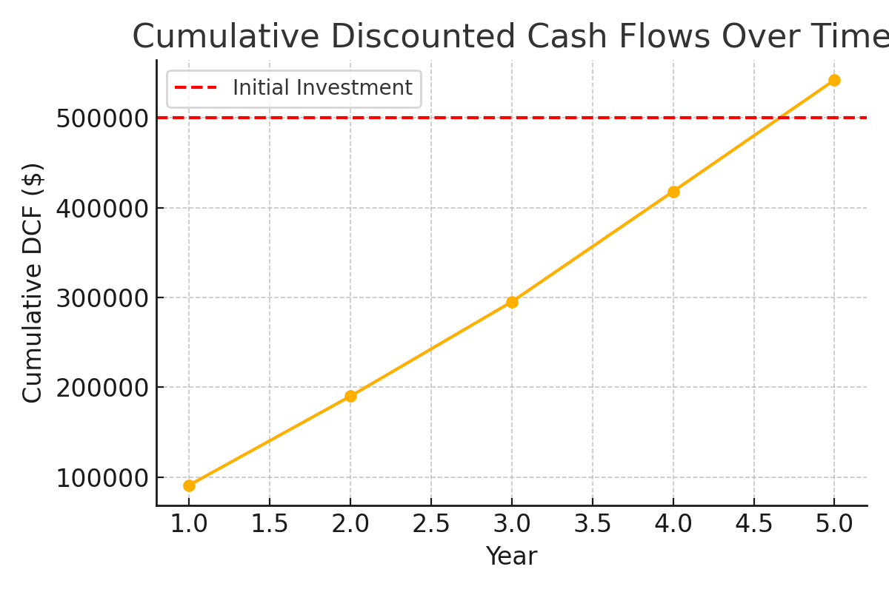

Comparison of Capital Budgeting Metrics
Each financial metric offers unique insights into Project A’s viability:
- Net Present Value (NPV) of $42,393.40 shows the project is expected to generate more value than it costs, indicating strong financial justification.
- Internal Rate of Return (IRR) of 12.89% exceeds the assumed discount rate of 10%, confirming the investment’s potential to yield a return greater than the cost of capital.
- Payback Period of 3.78 years highlights the time needed to recover the initial investment, offering insight into liquidity and risk exposure.
While NPV provides the most comprehensive picture of long-term profitability, IRR supports this by validating return efficiency. The Payback Period complements both by addressing short-term financial recovery. Together, these tools support a well-rounded investment decision

Decision-Making and Analysis
1. **Which project is more financially viable based on NPV and IRR?**
Project B is more financially viable, offering a higher NPV and IRR than Project A.
2. **If the company has a short-term liquidity constraint, which project is better based on the payback period?**
Project B is preferable under liquidity constraints as it offers a slightly faster payback period (3.75 years).
3. **What are the limitations of each investment appraisal method?**
- NPV assumes a constant discount rate and does not consider project scale.
- IRR can be misleading with unconventional cash flows.
- Payback Period ignores cash flows after recovery and time value of money.
- NRV does not consider the timing of cash inflows.
4. **If sustainability is a priority, how might non-financial factors influence the investment decision?**
Project A may contribute more significantly to renewable energy initiatives, while Project B could enhance energy efficiency. Non-financial factors like environmental impact, brand reputation, and alignment with corporate sustainability goals should be considered.

Conclusion and Recommendation
Project A: Solar Panel Manufacturing Expansion is financially viable, with positive NPV, acceptable IRR, and a manageable payback period. Based on this analysis, it is recommended that Eco Build Constructions proceed with the investment.

References
- (NPV). Retrieved from https://www.investopedia.com/terms/n/npv.asp
- Investopedia. (n.d.). Internal Rate of Return (IRR). Retrieved from https://www.investopedia.com/terms/i/irr.asp
- Investopedia. (n.d.). Payback Period. Retrieved from https://www.investopedia.com/terms/p/paybackperiod.asp

