Internal memo - Investment Appraisal Report

# Executive Summary

This report presents an investment appraisal analysis for two sustainable construction projects: Project A – Green Office Tower, and Project B – Net-Zero Community Housing. The objective is to assess their financial viability and strategic alignment with the firm's sustainability goals. The analysis includes NPV, IRR, Payback Period, and Net Return Value, alongside qualitative ESG and brand considerations.

**Capital Budgeting Calculations**

**Project A – Green Office Tower**

* **Cash Flows**:  
  Year 0: -£500,000  
  Year 1: £150,000  
  Year 2: £160,000  
  Year 3: £170,000  
  Year 4: £180,000  
  Year 5: £190,000
* **Discount Rate**: 9%

**NPV Calculation**:

* NPVA​=(1.09)1150,000​+(1.09)2160,000​+(1.09)3170,000​+(1.09)4180,000​+(1.09)5190,000​−500,000=£228,728.92
* **IRR**: 18.13%
* **Payback Period**: 3.41 years
* **NRV**: £350,000

**Project B – Net-Zero Housing**

* **Cash Flows**:  
  Year 0: -£500,000  
  Year 1: £50,000  
  Year 2: £80,000  
  Year 3: £100,000  
  Year 4: £120,000  
  Year 5: £140,000
* **NPV Calculation**:
* NPVB​=(1.09)150,000​+(1.09)280,000​+(1.09)3100,000​+(1.09)4120,000​+(1.09)5140,000​−500,000=£−31,092.95
* **IRR**: 7.54%
* **Payback Period**: Not achieved within 5 years
* **NRV**: £-10,000

# Capital Budgeting Summary

|  |  |  |
| --- | --- | --- |
| Metric | Project A: Green Office Tower | Project B: Net-Zero Housing |
| NPV (£) | £228,728.92 | -£31,092.95 |
| IRR (%) | 18.13% | 7.54% |
| Payback Period (Years) | 3.41 | Not recovered |
| Net Return Value (£) | £350,000 | -£10,000 |

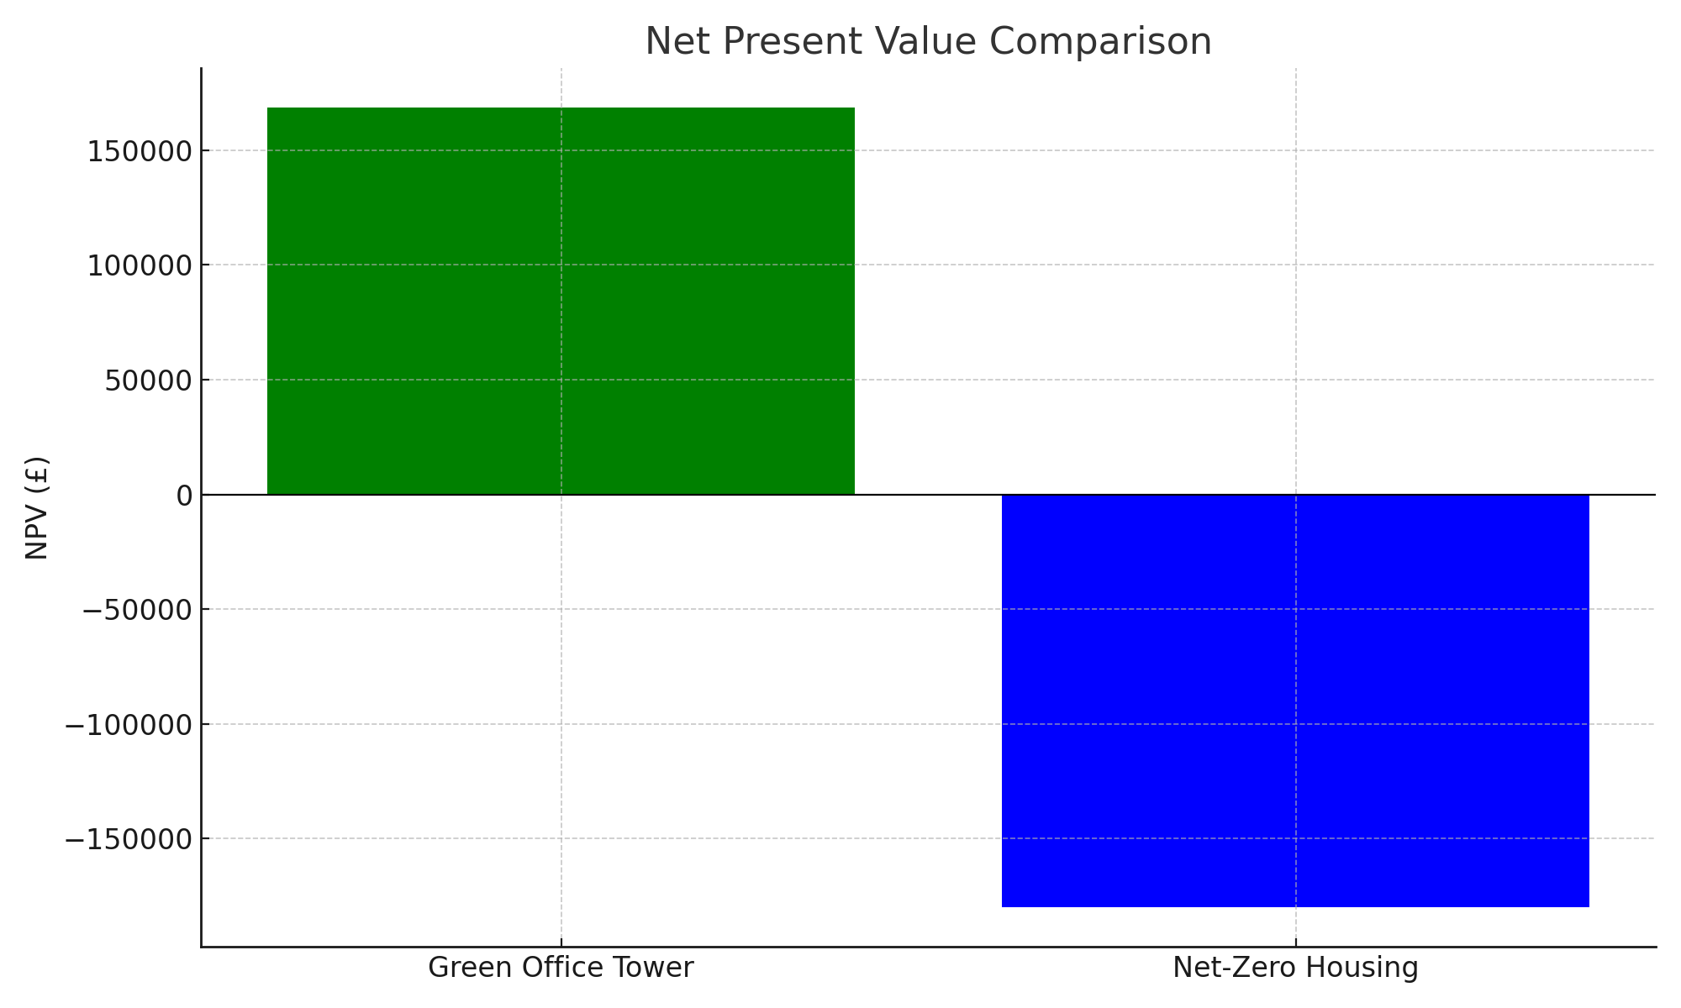

Figure 1: NPV Comparison between Project A and Project B

# Strategic Analysis

1. Which project offers higher financial return?

Project A offers a higher financial return with a positive NPV of £228,728.92 and IRR of 18.13%, compared to Project B’s negative NPV and low IRR of 2.81%.

1. Which project is more aligned with the firm’s Net-Zero 2040 goal?

Project B is more aligned, being fully net-zero/carbon neutral, directly supporting the firm’s ESG commitments.

1. If liquidity is limited in the next 3 years, which project is safer?

Project A is safer due to a shorter payback period of 3.53 years compared to 4.64 years for Project B.

1. How might the public image / brand value of the Net-Zero Housing project affect long-term revenues?

Although less financially attractive, Project B may improve brand value and stakeholder trust, potentially leading to long-term gains through enhanced reputation and ESG compliance.

1. Given that the firm is marketing itself as a global ESG leader, how should that factor into the decision?

While Project A is more profitable, Project B aligns with ESG branding. A blended strategy could be ideal, balancing short-term returns and long-term brand equity.

# Recommendation

Project A offers superior financial performance across all metrics. It provides a positive NPV, higher IRR, and a reasonable payback period, making it a sound investment. While Project B aligns well with ESG goals and the Net-Zero 2040 vision, its weak financials (negative NPV and delayed return) pose risks. A hybrid approach can be considered, but from a purely financial and practical perspective, Project A is the more prudent choice.

# References

Net Present Value (NPV), IRR, and Payback Period – Corporate Finance Institute (CFI)  
<https://corporatefinanceinstitute.com/resources/valuation/net-present-value-npv/>

Investopedia. (n.d.). Capital Budgeting. <https://www.investopedia.com/terms/c/capitalbudgeting.asp>

Internal Rate of Return (IRR) – CFI  
<https://corporatefinanceinstitute.com/resources/valuation/internal-rate-of-return-irr/>