Internal memo - Investment Appraisal Report

Executive Summary
This report presents an investment appraisal analysis for two sustainable construction projects: Project A – Green Office Tower, and Project B – Net-Zero Community Housing. The objective is to assess their financial viability and strategic alignment with the firm's sustainability goals. The analysis includes NPV, IRR, Payback Period, and Net Return Value, alongside qualitative ESG and brand considerations.
Capital Budgeting Calculations
Project A – Green Office Tower
- Cash Flows:
Year 1: £300,000
Year 2: £340,000
Year 3: £360,000
Year 4: £380,000
Year 5: £400,000
- Discount Rate: 9%
- Initial investment: £1,200,000
NPV Calculation:
- NPV=1.091300,000​+1.092340,000​+1.093360,000​+1.094380,000​+1.095400,000​−1,200,000=£168,560.74
- IRR: 14.02%
- Payback Period: Cumulative cash flow to recover £1,200,000:
End of Year 1: £300,000
Year 2: £640,000
Year 3: £1,000,000
Year 4: £1,380,000
Payback occurs between Year 3 and Year 4:
- Payback=3+1,200,000−1,000,000 divided by 380,000 = 3.53 years
- NRV:
Total Cash Inflows=300K+340K+360K+380K+400K=£1,780,000
NRV = 1,780,000 – 1,200,000 = £580,000

Project B – Net-Zero Housing
- Cash Flows:
Year 1: £200,000
Year 2: £220,000
Year 3: £240,000
Year 4: £260,000
Year 5: £280,000
- Discount rate: 9%
- Initial investment: £1,100,000
- NPV Calculation:
NPV=1.091200,000​+1.092220,000​+1.093240,000​+1.094260,000​+1.095280,000​−1,100,000=−£179,848.78​
- IRR: 2.81%
- Payback Period:
Cumulative inflows:
End of Year 1: £200K
Year 2: £420K
Year 3: £660K
Year 4: £920K
Year 5: £1,200K
Payback happens in Year 5:
- Payback=4+1,100,000−920,000 divide 280,000 = 4.64 years
- NRV:
NRV=200K+220K+240K+260K+280K−1,100,000=£100,000

Capital Budgeting Summary
Metric | Project A: Green Office Tower | Project B: Net-Zero Housing
NPV (£) | £168,560.74 | -£179,848.78
IRR (%) | 14.02% | 2.81%
Payback Period (Years) | 3.53 | 4.64
Net Return Value (£) | £580,000 | £100,000

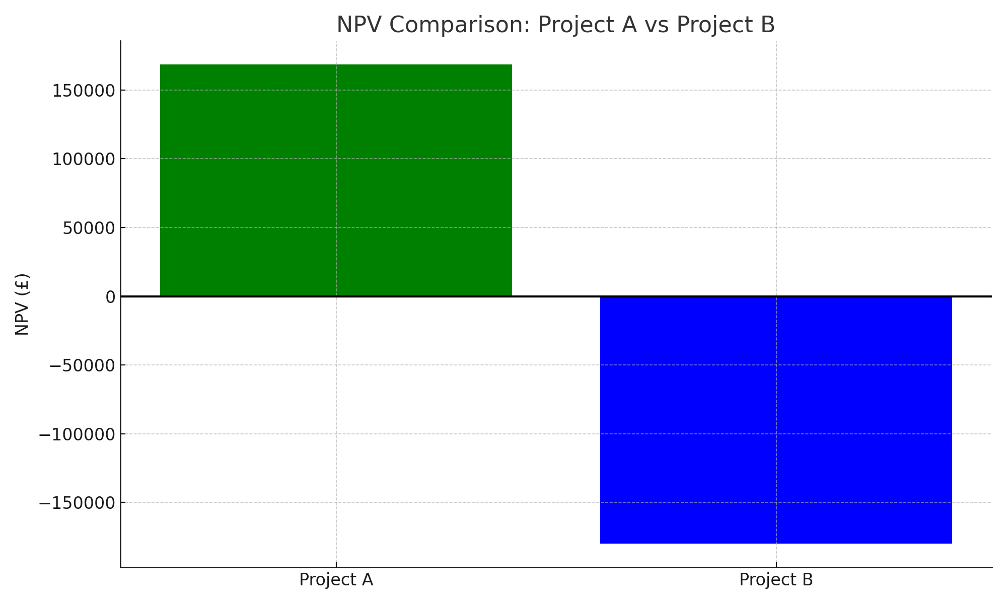

Figure 1: NPV Comparison between Project A and Project B

Strategic Analysis
- Which project offers higher financial return?
Project A: Green Office Tower offers the higher financial return.
NPV: £168,560.74 (positive) vs. Project B’s negative NPV of -£179,848.78.
IRR: 14.02% (well above the 9% discount rate) vs. Project B’s 2.81% (below discount rate).
Payback Period: 3.53 years for Project A is shorter than 4.64 years for Project B.
Net Return Value: £580,000 vs. £100,000.
This indicates Project A is more financially attractive and recovers its investment faster.

- Which project is more aligned with the firm’s Net-Zero 2040 goal?
Project B: Net-Zero Community Housing is more aligned with the Net-Zero 2040 goal.
It achieves full net-zero carbon neutrality, compared to Project A’s 30% reduction in energy consumption.
This aligns better with ambitious sustainability targets and long-term environmental commitments.

- If liquidity is limited in the next 3 years, which project is safer?
Project A is safer given liquidity constraints.
Its payback period is 3.53 years, meaning the initial investment is recovered sooner than Project B’s 4.64 years.
Higher and quicker cash inflows reduce liquidity risk.
Project B’s cash inflows are lower and payback occurs later, increasing short-term liquidity risk.

- How might the public image / brand value of the Net-Zero Housing project affect long-term revenues?
The Net-Zero Housing project could significantly enhance the firm’s brand reputation as an ESG leader, attracting customers and investors interested in sustainability.
This positive public image can translate into higher demand, premium pricing, and better stakeholder relationships, potentially increasing long-term revenues beyond the direct financial returns.
It may also open doors to subsidies, grants, or partnerships related to green building initiatives.

- Given that the firm is marketing itself as a global ESG leader, how should that factor into the decision?
The company should weigh strategic, non-financial benefits alongside financial returns.
While Project A is financially superior, Project B supports the ESG brand and mission, positioning the firm as a pioneer in net-zero development.
A balanced approach might involve prioritizing Project A for immediate returns while investing in Project B for long-term brand equity and market positioning aligned with the Net-Zero 2040 commitment.
Alternatively, the firm could seek ways to improve Project B’s financial performance (e.g., cost reductions, subsidies) to align both financial and ESG goals.

Recommendation
After thorough analysis, Project A, the Green Office Tower, clearly delivers stronger financial returns with a positive NPV of £168,560.74, a robust IRR of 14.02%, and a quicker payback period of 3.53 years, making it the safer choice under liquidity constraints. However, Project B, the Net-Zero Community Housing, aligns more closely with the firm’s Net-Zero 2040 sustainability goals by achieving full carbon neutrality, which is crucial for reinforcing the company’s position as a global ESG leader. While Project B’s current financial outlook is weaker, its potential to enhance brand reputation and attract environmentally conscious investors and clients could drive long-term revenue growth beyond immediate cash flows. Therefore, the firm should balance immediate financial viability with strategic ESG commitments—potentially prioritizing Project A for short-term gains while supporting Project B’s development to secure sustainable competitive advantage and fulfill its environmental mission.

References

Net Present Value (NPV), IRR, and Payback Period – Corporate Finance Institute (CFI)
https://corporatefinanceinstitute.com/resources/valuation/net-present-value-npv/
Investopedia. (n.d.). Capital Budgeting. https://www.investopedia.com/terms/c/capitalbudgeting.asp
Internal Rate of Return (IRR) – CFI
https://corporatefinanceinstitute.com/resources/valuation/internal-rate-of-return-irr/

