Capital Budgeting & Investment Appraisal – Task 14

# Introduction

In this task, I will conduct a comprehensive capital budgeting analysis for two competing projects: Project A (Energy-Positive Modular School Buildings) and Project B (Recycled Steel Prefab Commercial Units). This includes calculating the Net Present Value (NPV), Internal Rate of Return (IRR), payback period, and preparing visual analyses through graphs. The objective is to determine which project is financially more viable for investment.

# 1. Cash Flow & Present Value (PV) Table

|  |  |  |  |  |  |  |
| --- | --- | --- | --- | --- | --- | --- |
| Year | Cash Flow A | PV A | Cash Flow B | PV B | Discount Factor | Year |
| 1 | £220,000.00 | £200,000.00 | £200,000.00 | £181,818.18 | 0.9091 | 1 |
| 2 | £240,000.00 | £198,347.11 | £280,000.00 | £231,404.96 | 0.8264 | 2 |
| 3 | £210,000.00 | £157,776.11 | £250,000.00 | £187,828.70 | 0.7513 | 3 |
| 4 | £300,000.00 | £204,904.04 | £220,000.00 | £150,262.96 | 0.6830 | 4 |
| 5 | £330,000.00 | £204,904.04 | £270,000.00 | £167,648.76 | 0.6209 | 5 |

**Present Value (PV) Calculations**

**Year 1**

* Discount Factor = 1 / (1 + 0.10)^1 = **0.9091**
* Project A PV = £220,000 × 0.9091 = **£200,000.00**
* Project B PV = £200,000 × 0.9091 = **£181,818.18**

**Year 2**

* Discount Factor = 1 / (1 + 0.10)^2 = **0.8264**
* Project A PV = £240,000 × 0.8264 = **£198,347.11**
* Project B PV = £280,000 × 0.8264 = **£231,404.96**

**Year 3**

* Discount Factor = 1 / (1 + 0.10)^3 = **0.7513**
* Project A PV = £210,000 × 0.7513 = **£157,776.11**
* Project B PV = £250,000 × 0.7513 = **£187,828.70**

**Year 4**

* Discount Factor = 1 / (1 + 0.10)^4 = **0.6830**
* Project A PV = £300,000 × 0.6830 = **£204,904.04**
* Project B PV = £220,000 × 0.6830 = **£150,262.96**

**Year 5**

* Discount Factor = 1 / (1 + 0.10)^5 = **0.6209**
* Project A PV = £330,000 × 0.6209 = **£204,904.04**
* Project B PV = £270,000 × 0.6209 = **£167,648.76**

Total PV for Project A: £965,931.29

Total PV for Project B: £918,963.56

# 2. NPV & IRR Calculation

**NPV:**

**Project A**:  
NPV = Total PV − Initial Investment  
= £965,931.29 − £900,000 = **£65,931.29**

**Project B**:  
NPV = Total PV − Initial Investment  
= £918,963.56 − £850,000 = **£68,963.56**

The Internal Rate of Return (IRR) is the discount rate at which the Net Present Value (NPV) of a project becomes zero. It represents the project’s break-even cost of capital.

**IRR:**

**Project A – Energy-Positive Modular School Buildings**

* **Initial Investment:** £900,000
* **Future Cash Flows:** £220,000, £240,000, £210,000, £300,000, £330,000
* **Calculated IRR:** **13.3%**

**Project B – Recycled Steel Prefab Commercial Units**

* **Initial Investment:** £850,000
* **Future Cash Flows:** £200,000, £280,000, £250,000, £220,000, £270,000
* **Calculated IRR:** **14.6%**

**Interpretation:**  
Project B offers a slightly higher IRR, indicating a more efficient return per pound invested. However, this should be considered alongside NPV and other strategic factors when making a final decision.

# 3. Payback Period Analysis

|  |  |  |  |
| --- | --- | --- | --- |
| Year | Cumulative Cash Flow A | Cumulative Cash Flow B | Recovered? |
| 1 | £220,000.00 | £200,000.00 | No |
| 2 | £460,000.00 | £480,000.00 | No |
| 3 | £670,000.00 | £730,000.00 | No |
| 4 | £970,000.00 | £950,000.00 | Yes |
| 5 | £1,300,000.00 | £1,220,000.00 | Yes |

Project A pays back in approximately Year 4 with partial year: 3.77

Project B pays back in approximately Year 4 with partial year: 3.55

# 4. Graphs & Visual Analysis

Below are visual charts supporting the financial analysis:

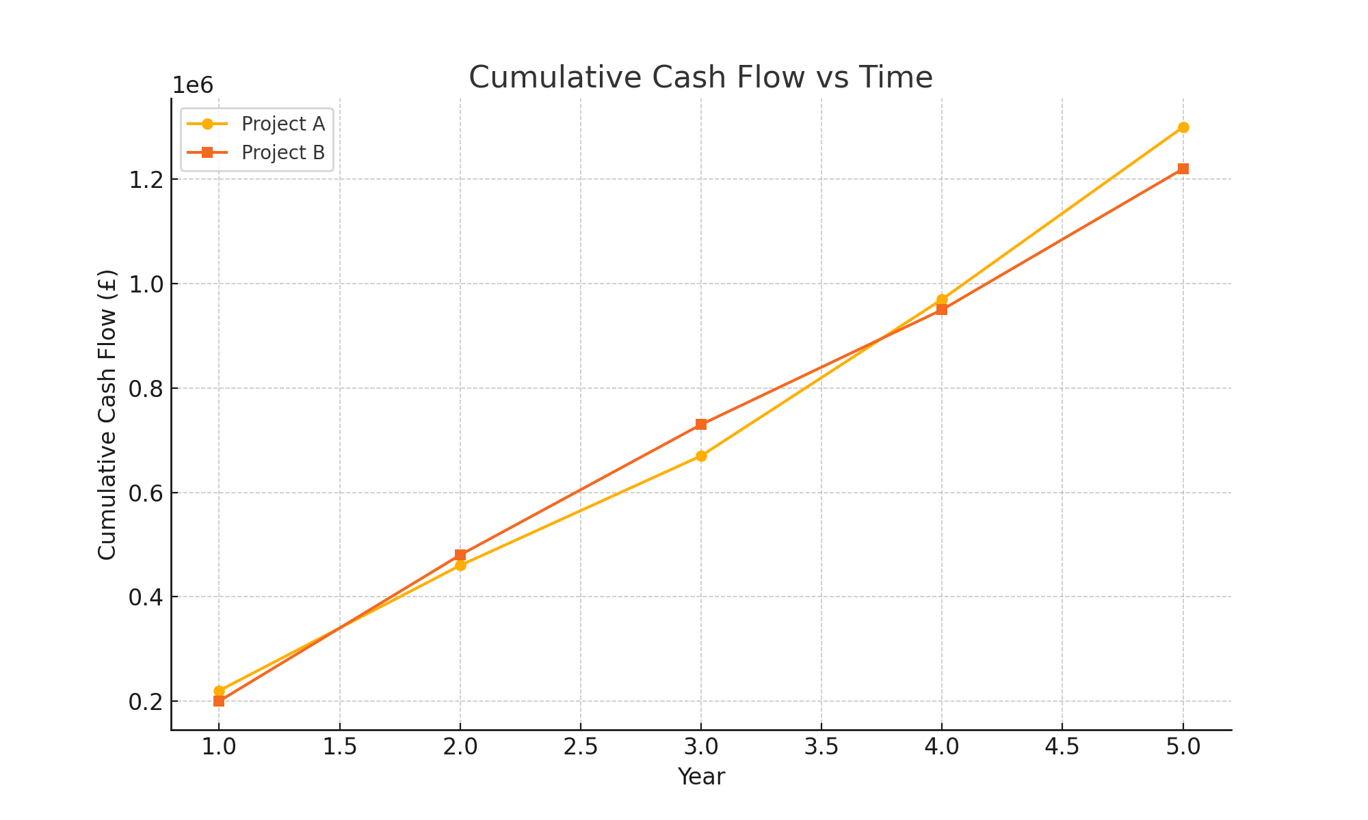

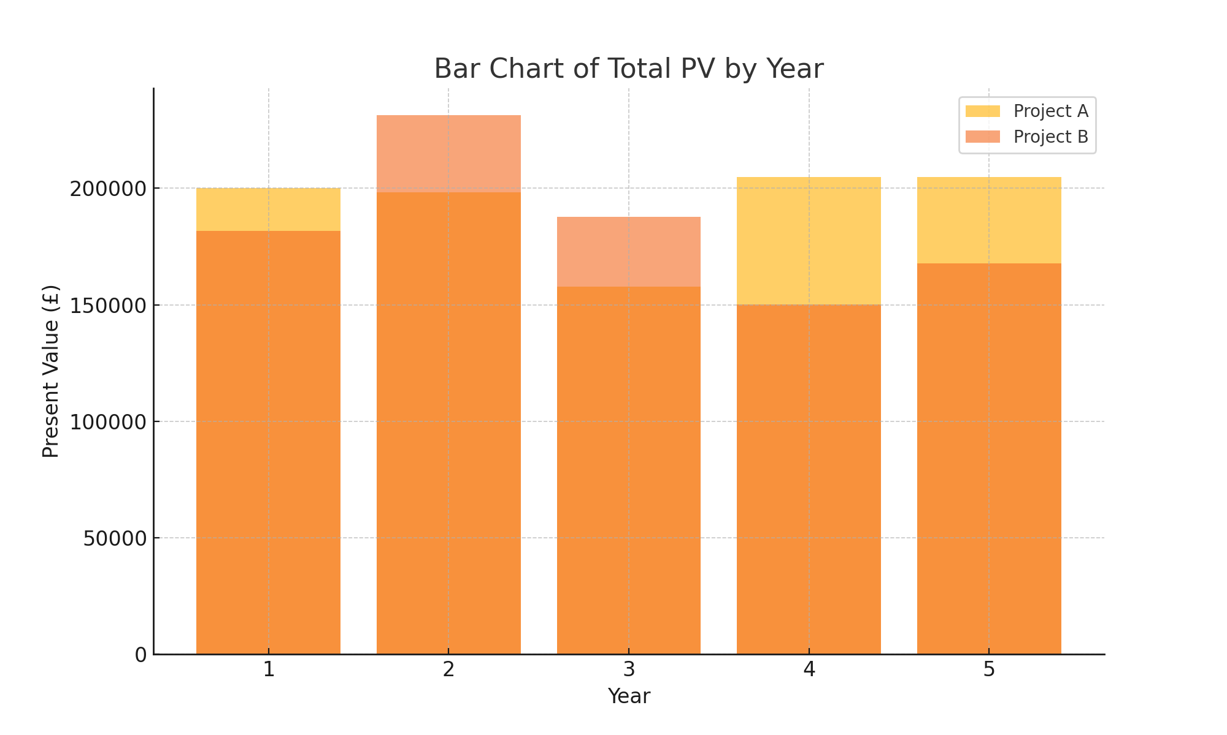

# 5. Strategic Discussion

# 1. Project B offers better financial returns overall. It has a slightly higher Net Present Value (NPV) of £68,963.56, compared to £65,931.29 for Project A. In addition, Project B has a higher Internal Rate of Return (IRR) of 14.6%, while Project A's IRR is 13.3%. This means that, financially, Project B provides a more efficient and valuable return on investment.

# 2. Project B also pays back the initial investment slightly sooner than Project A. The calculated payback period for Project B is 3.55 years, while Project A takes 3.77 years to recover its investment. This faster payback suggests lower short-term risk and quicker access to reinvested capital.

# 3. In terms of cash flow variability, Project A appears to be more stable. Its inflows increase gradually over the five years, ending with a strong cash flow of £330,000 in Year 5. Project B, while delivering higher early returns such as £280,000 in Year 2, shows more fluctuation and a slight decline in later years. This indicates that Project A may present less risk from unpredictable cash flow performance over time.

# 4. If environmental marketing value is taken into account, this could strongly influence the recommendation in favour of Project A. The project involves energy-positive modular school buildings, which support sustainable development and align with environmental priorities. This could enhance the organisation’s public image, attract eco-conscious investors, and potentially qualify for environmental grants or government incentives, making Project A more appealing beyond just financial metrics.

# 5. The final recommendation depends on strategic priorities. From a purely financial perspective, Project B is the stronger choice due to its higher NPV, higher IRR, and quicker payback period. However, if long-term environmental benefits, brand reputation, and sustainability objectives are important to the organisation, then Project A may be the better option. Each project has merit, but based solely on the financial analysis provided, Project B is recommended.

# 6. References

**Investopedia. (2024). Net Present Value (NPV).** <https://www.investopedia.com/terms/n/npv.asp>

**Investopedia. (2024). Internal Rate of Return (IRR).** <https://www.investopedia.com/terms/i/irr.asp>

**Corporate Finance Institute (CFI). (2023). Payback Period.**  
<https://corporatefinanceinstitute.com/resources/valuation/payback-period/>