Each of the three segments, Consumer, Pharmaceuticals and Medical Devices have sub segments with product lines like Remicade, Darzalex , Stelara and Tremfya or Surgery, Orthopaedics and Intervention solutions. All of these lines have US & International sales. US revenue can be driven by annual growth rates, international revenue growth has two components, organic growth and currency impact.

Johnson and Johnson total sales revenue for 2022 worldwide totalled $94'943 billion
The revenue was generated from the following:
Pharmaceuticals
The company discovers, develops, and sells pharmaceutical products globally. Its drugs are used for the treatment of various types of diseases, including cancer, heart-related, and infectious diseases, among others.
The pharmaceutical segment of Johnson & Johnson generates the majority of the company's sales. This division accounted for more than half of J&J's revenue for the full year. At just 60% of overall revenue, pharmaceuticals drew in a total of $52'563 billion in sales.
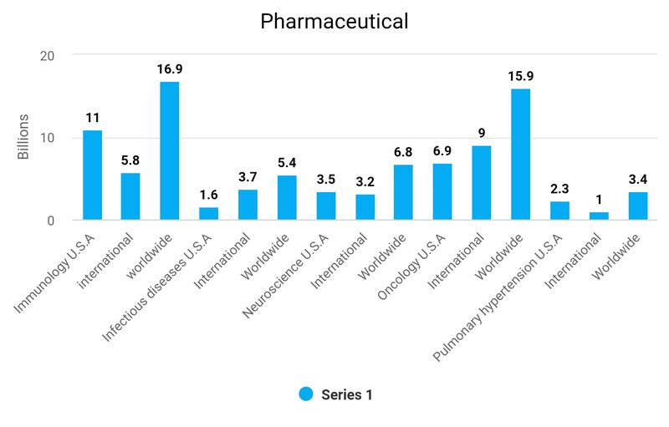

The largest individual product, a drug named Stelara generated 10% of total revenue alone, making up 16% of the entire pharmaceutical segments revenue.
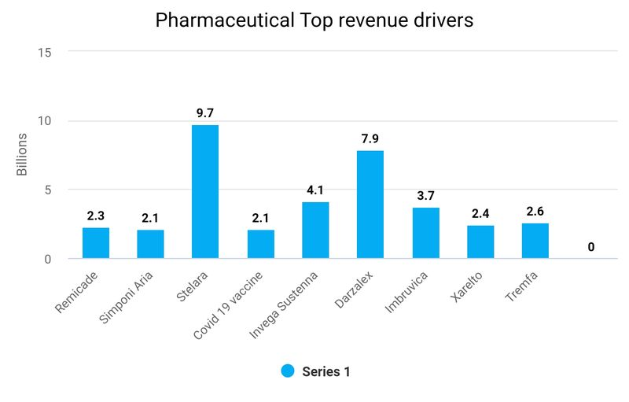

Medical Devices
This division is divided into four different areas, including:
Orthopaedics: joint reconstruction, trauma, spine, sports medicine, and power tools
Surgery: surgical systems and instruments
Interventional solutions: heart rhythm disorders and neurovascular care support for health care professionals
Revenue from Medical devices generated about $27'427 billion in sales, which represented 29% of total revenue.
The highest individual generators of revenue are Med tech surgery supplies generating 10% of total revenue and Orthopaedics at 9%

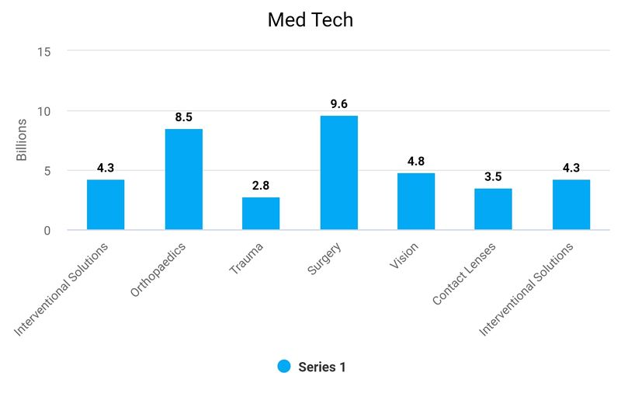

Consumer Products
Johnson & Johnson's consumer products segment offers a broad range of products used in three distinct categories:
Skin health
Self-care
Essential health
These categories provide consumers with a wide range of products ranging from baby care, oral care, beauty products, women's health, wound care, to over-the-counter medicines.
This segment of the company was responsible for 16% of total sales, representing $14'953 billion of revenue.

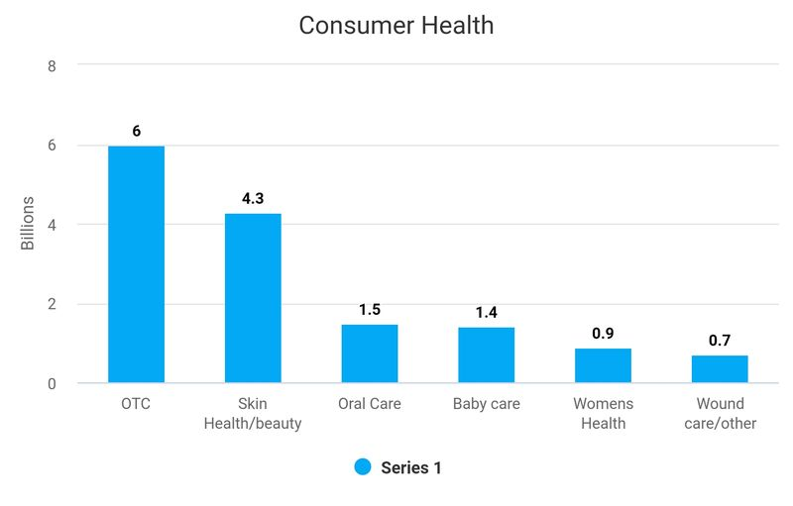

Cost Drivers – as % of revenue (trend analysis)
- Selling, Marketing and Administrative Expenses
- Research and Development Expenses
- In-process research and development
- Cost of products sold
Cost Drivers – as % of revenue (trend analysis)
- Selling, Marketing and Administrative Expenses
- Research and Development Expenses
- In-process research and development
- Cost of products sold
Cost Drivers – as % of revenue (trend analysis)
- Selling, Marketing and Administrative Expenses
- Research and Development Expenses
- In-process research and development
- Cost of products sold
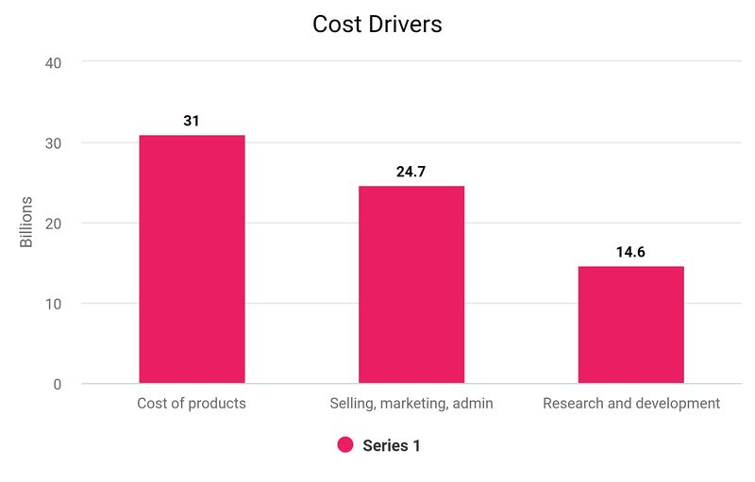
Cost Drivers – as % of revenue (trend analysis)
- Selling, Marketing and Administrative Expenses
- Research and Development Expenses
- In-process research and development
- Cost of products sold

Total revenue was 94943, cost of goods, research and development, selling marketing and administrative totalled 70457 equating to 74% of revenue.

Total revenue after cost drivers deducted was around 26%, anything over 20% is considered very good and I conclude that this is an impressive return for the company.

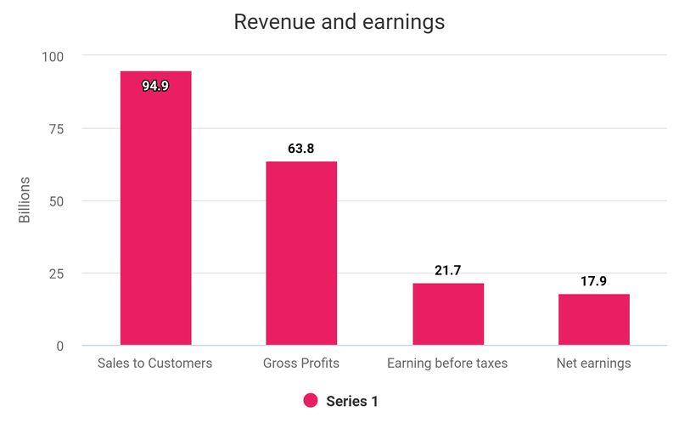

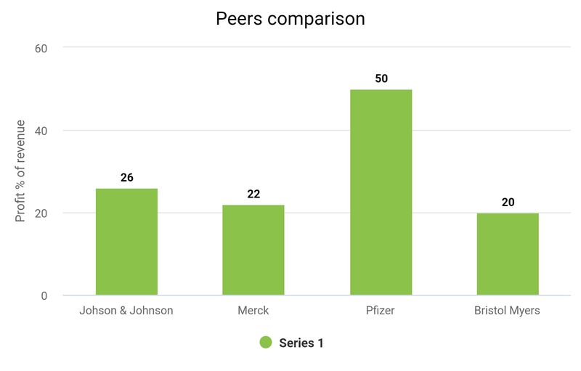
Merck total revenue for 2022 was 22232, cost of sales was 8527 equating to 39% of revenue.
Research and development, administration expenses, marketing and selling expenses totalled 8521, 39% of revenue. Combined this equates to 78% of total revenue.
Pfizer total revenue 2022 was 100,330, Cost of sales was 34,344 equating to 34% of revenue.
Research and development, administration expenses, marketing and selling expenses totalled 26,058 26% of revenue. Combined this equates to 50% of revenue and has far exceeded Johnson and Johnson performance.

Bristal Myers total revenue for 2022 was 46159, Cost of sales was 10137 equating to 22% of revenue.
Research and development, administration expenses, marketing and selling expenses totalled 17323 38% of revenue. Amortisation of intangible assets totalled 9,595, 20% of revenue.
Combined this equates to 80% of revenue.
Johnson and Johnson is performing well in comparison to its peers and outperforming them in terms of revenue/cost drivers returns, all except for Pfizer who had an extraordinary year.

